JUNIOR SCHOOL EDUCATION ASSESSMENT

GRADE 9 MIDTERM TERM 2 ASSESSMENT

MATHEMATICS Time: 2 Hours.

Learner’sName:______________________Assessment No:_____________

SCHOOL:_______________________________________

SECTION A (20 MARKS)
Answer ALL questions in this section.

What is thirteen million, three hundred and thirty-three thousand, three hundred and six and three thousandths written in symbols?
A. 13303306.003
B. 3333303.003
C. 13333306.003
D. 13333306.3

WORKING SPACE

A teacher presented flash cards with the following numbers and asked learners to identify integers only. Which learner gave the correct answer?
Numbers: 3, 0.5, -16, 2¼, $\frac{1}{2}$, 0
A. Moses → 2¼, 1, ½ , 0.5
B. Grace → 3, -16, 0
C. Gavin → ½ , -16, 0.5
D. Jean → 0, 3, 0.5

Omwami was asked by his teacher to find the cube of 784.6 using mathematical tables. Which of the following was the correct answer?
A. 4 828 254.65
B. 482 825 465
C. 482 997 531.736
D. 482 010 000

What is the value of:
$$\frac{0.21×0.35 ×26.7}{0.7×0.03×0.89}$$
A. 1.05
B. 105
C. 1 050
D. 0.105

Kamau used ½ of his salary to pay rent, ¼ for fees, and saved the rest. How much did he save if he earns a salary of sh 80,000 per month?
A. Sh 50 000 B. Sh 30 000
C. Sh 40 000 D. Sh 25 000

WORKING SPACE

Express the number 0.0000000948 in standard form:
A. 9.48 × 10⁻⁸
B. 94.8 × 10⁸
C. 9.48 × 10⁸
D. 948 × 10⁻⁸

Determine the value of:
$$\frac{\left(-4\right)+\left(+3\right)×\left(-5\right)-\left(-8\right)÷\left(+2\right)}{3}$$A. -15
B. 5
C. -5
D. 15

Twelve men working at the same rate were hired to complete a piece of work in 36 days. If 4 men failed to report, how many more days did the remaining men take to complete the work?
A. 48 days
B. 54 days
C. 18 days
D. 36 days

What is the value of p in the equation:
$$\left(\left(\frac{2p+3}{5}\right)+\frac{2+p}{2}\right)= 7$$
A. 6
B. 5
C. 4
D. 3

WORKING SPACE

Which of the following inequalities represents the wanted region in the graph below?
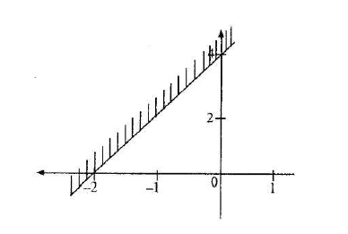
A. y ≥ 3x + 3
B. y ≤ ½x+ 4
C. y =2x + 4
D. y < -2

The cash price of a sofa set is sh 16 000. Muli bought it on hire purchase terms. The total amount he paid was 25% more than the cash price. He paid a deposit of sh 2 000 and the rest in 12 equal monthly instalments. How much was each instalment?

A. Sh 18 000
B. Sh 1 500
C. Sh 1 600
D. Sh 3 000

WORKING SPACE

During the election of the African Union Chairperson, the winning candidate got $\frac{3}{5}$ of the votes cast, while the other two candidates got $\frac{1}{5}$ and $\frac{1}{10}$ respectively. The remaining votes were spoilt. If there were 1,200 spoilt votes, how many votes were cast altogether?
A. 12 000
B. 6 000
C. 3 600
D. 10 000

In the figure below, WX is the diameter of the semicircle.
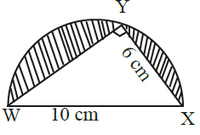

Find the area of the shaded part. (π = 3.14)
A. 39.25 cm²
B. 15.25 cm²
C. 24 cm²
D. 63.25 cm²

A water tank has a radius of 3.5 m and a height of 4 m. What is the capacity of the tank in litres when the tank is ¾ full? (Take π = $\frac{22}{7}$ )
A. 115.5 B. 154
C. 115 500 D. 154 000

WORKING SPACE

Omondi borrowed Sh 200000 from a bank to buy a piece of land. The bank charged compound interest at a rate of 12% per year. How much money did he pay altogether after two years?
A. Sh 24 000 B. Sh 26 880
C. Sh 224 000 D. Sh 250 880

The figure below shows a water trough.

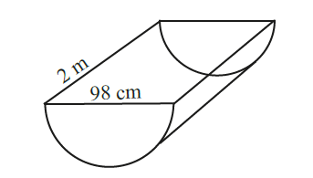

Find its outer surface area. (π = 22/7)
A. 2.2946 m²
B. 3.08 m²
C. 3.8346 m²
D. 30 800 m²

Esther bought items from a shop and paid with sh 1000.
- 4 exercise books @ sh 40 each
- 250 g cooking fat at sh 120 per kg
- ¾ kg of nails for sh 100
- 2 bars of soap @ sh 150 each
- ½ litres of milk at sh 60 per litre

What was her balance?
A. Sh 380 B. Sh 480
C. Sh 620 D. Sh 720

WORKING SPACE

Find the total surface area of the triangular prism.
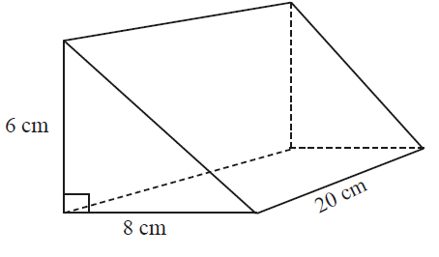
A. 648 cm²
B. 408 cm²
C. 528 cm²
D. 248 cm²

Construct triangle XYZ in which XY = 7 cm, YZ = 6 cm and XZ = 5 cm. Draw a circle that touches the vertices of the triangle. Find the radius of the circle.
A. 3 cm
B. 4.1 cm
C. 3.6 cm
D. 7.2 cm

The length of different sticks were recorded as follows: 6cm, 7cm, 4cm, 2cm, 5cm, 2cm

What is the median of these lengths?
A. 9 cm
B. 4 cm
C. 5 cm
D. 4.5 cm

WORKING SPACE

SECTION B (30 MARKS)
Answer all questions in this section

Solve: (2 marks)
3^{(3 + x)} ÷ 27^{(x + 1)} = 9

Without using tables or a calculator, evaluate the following. (2 marks)
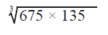

A construction company mixes cement, ballast and sand in the ratio 1:3:5. If the mass of sand was 720 kg, how many more kilograms of ballast than cement were used? (3 marks)

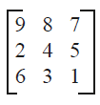
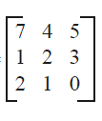

Given matrices A and B , find B – A. (2 marks)

Solve inequality: (2 marks)
3x – 2 > 2(x – 1) + 5x

Gradient = -$\frac{2}{5}$, passes through P(10,7). Find y-intercept. (2 marks)

Amos bought a car for sh 400 000. Each year, the value of the car depreciates by 8%. What will be the value of the car at the end of the second year? (3 marks)

The curved surface area of an open cylinder is 3 080 cm². If the height of the cylinder is 35 cm, calculate the radius of the cylinder. (3 marks)

A cyclist left town A for town B at 9:00 a.m. travelling at a speed of 150 km/h. He arrived at his destination at 11:00 a.m. He stayed in town B for one hour before travelling back to town A. At what speed did he travel from town B to A, if he arrived at town A at 3:00 p.m.? (3 marks)

Use the graph paper provided to solve the following simultaneous equations. (4 marks)
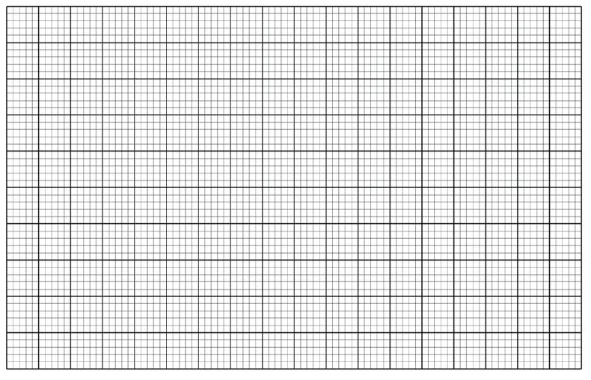
y + 3x = 6
y – 2x = -4

A group of learners measured a road found it to be 3 km. They drew the road in a book using a line 20 cm long to represent it. What scale did they use? (2 marks)

A Grade 9 class has 15 boys and 10 girls. What is the probability of randomly selecting a boy from the class? (2 marks)

MARKING SCHEME

SECTION A (20 MARKS)
No. | Answer
1 | C
2 | B
3 | B
4 | B
5 | B
6 | A
7 | C
8 | B
9 | A
10 | C
11 | B
12 | A
13 | B
14 | D
15 | D
16 | A
17 | A
18 | C
19 | D
20 | D

SECTION B

21. Equation
$$3\left(3+x\right)÷27\left(x+1\right)=9$$
Multiply both sides:
3(3+x) = 243(x+1)
9 + 3x = 243x + 243
-234x = 234
x = -1
✔ Answer: -1

22. Ratio
Ratio 1:3:5
Sand = 720 (5 parts)
1 part = 144
Cement = 144
Ballast = 432
Difference:
288 kg
✔ Answer: 288 kg

23. Matrix
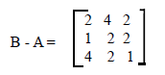

24. Inequality
3x – 2 > 2(x – 1) + 5x
3x – 2 > 7x – 2
0 > 4x
x < 0
✔ Answer: x < 0

25. Gradient
m = -2/5
Point (10,7):
7 = -4 + c
c = 11
✔ Answer: 11

26. Depreciation
$$A=400,000{\left(0.92\right)}^{2}$$
= 400,000 × 0.8464
= 338,560
✔ Answer: 338,560

27. Cylinder radius
$$3080=2πrh$$
= 220r
r = 14 cm
✔ Answer: 14 cm

28. Speed
Distance:
150 × 2 = 300 km
Time:
3 hours
Speed:
300 ÷ 3 = 100 km/h
✔ Answer: 100 km/h

29. Simultaneous equations
x = 2, y = 0
✔ Answer: (2,0)

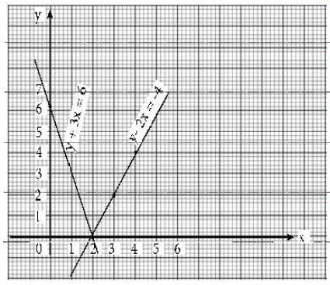

30. Scale
3 km = 300,000 cm
20 cm → 300,000 cm
Scale = 1:15,000
✔ Answer: 1:15,000

31. Probability
15 boys / 25 total
= $\frac{3}{5}$
✔ Answer: $\frac{3}{5}$

